**Bring dags folder in Desktop/apache airflow**

**Give following commands accordingly**

**steps to set airflow**

~$ cd Desktop/airflow-tutorial/

~Desktop/airflow-tutorial$ source ~/unset_jupyter.sh

~Desktop/airflow-tutorial$ echo $PYSPARK_DRIVER_PYTHON

~Desktop/airflow-tutorial$ echo $PYSPARK_DRIVER_PYTHON_OPTS

~Desktop/airflow-tutorial$ unset PYTHONPATH

~Desktop/airflow-tutorial$ conda activate airflow-tutorial

(airflow-tutorial)~Desktop/airflow-tutorial$ echo $AIRFLOW_HOME

(airflow-tutorial)~Desktop/airflow-tutorial$ code .

(airflow-tutorial)~Desktop/airflow-tutorial$ airflow resetdb / airflow initdb

(airflow-tutorial)~Desktop/airflow-tutorial$ airflow webserver

(airflow-tutorial)~Desktop/airflow-tutorial$ airflow scheduler

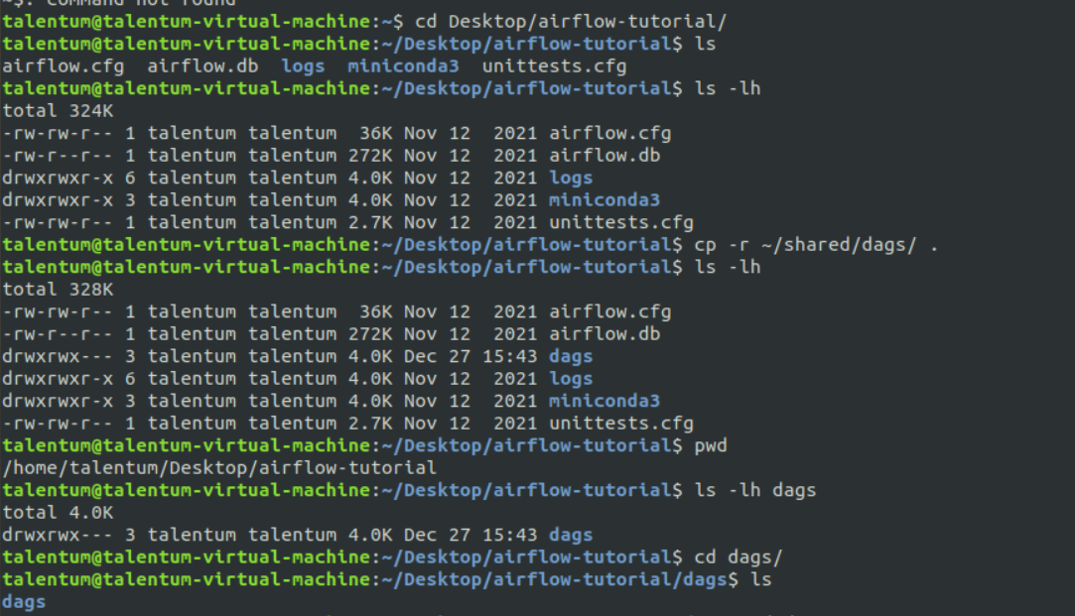

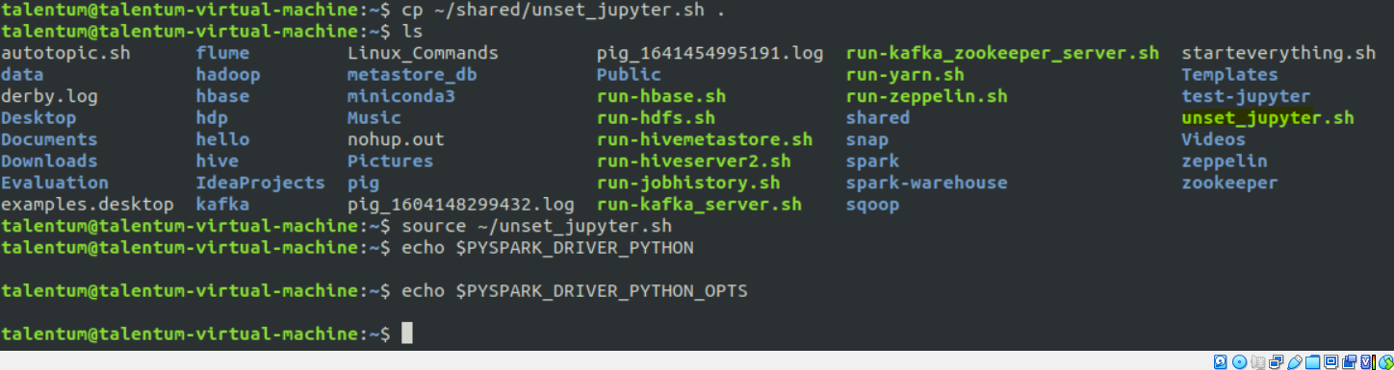



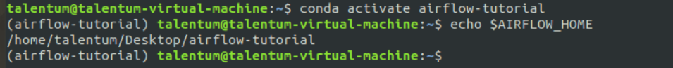

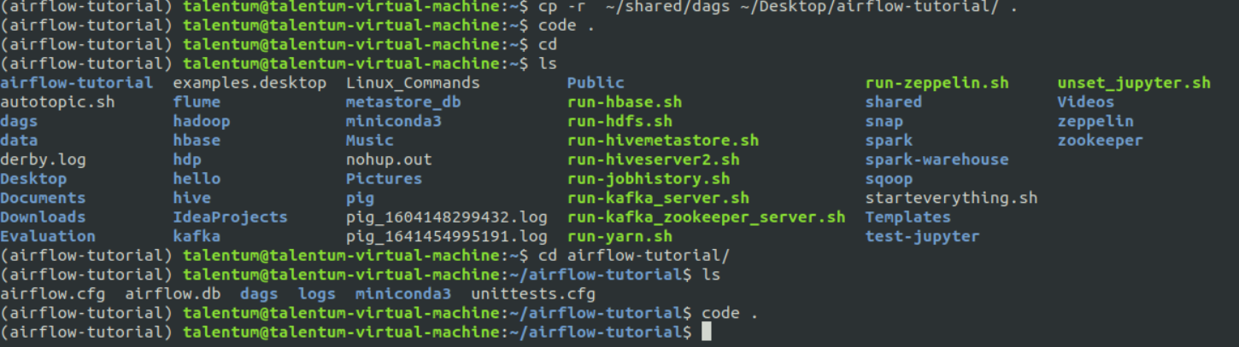

**After giving “code .” command it will open vs code (note- dag must be present on desktop airflow-tutorial folder**

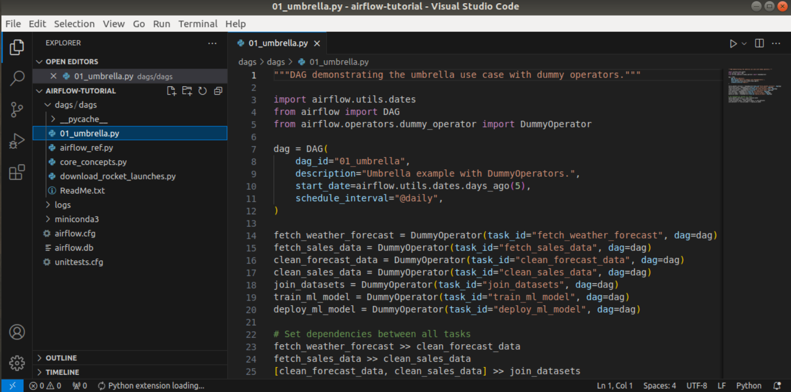

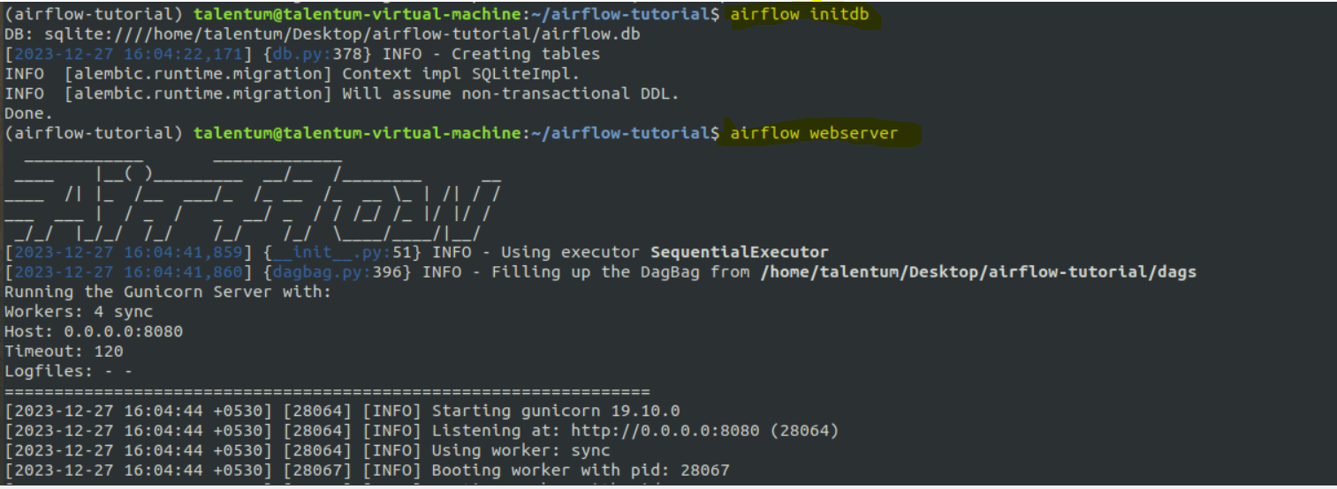

**(note-give “airflow initdb” when you are running first time on machine or else give “airflow resetdb”**

**Terminal will be blocked**

**For Schedular**

**In new terminal**

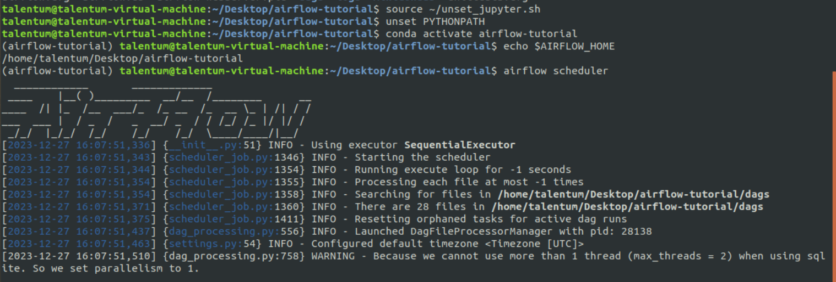

**In browser go to -> localhost:8080/admin/**

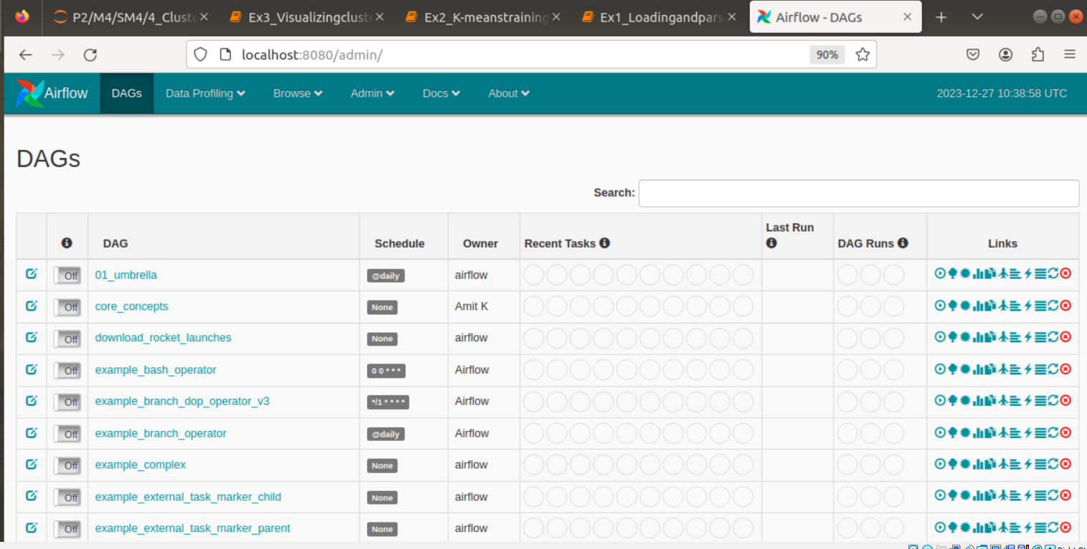

**Here soo many dags are present but I wany only particular dags go to vs code -> airflow.cfg**

**Go to this file**

**Shown below**

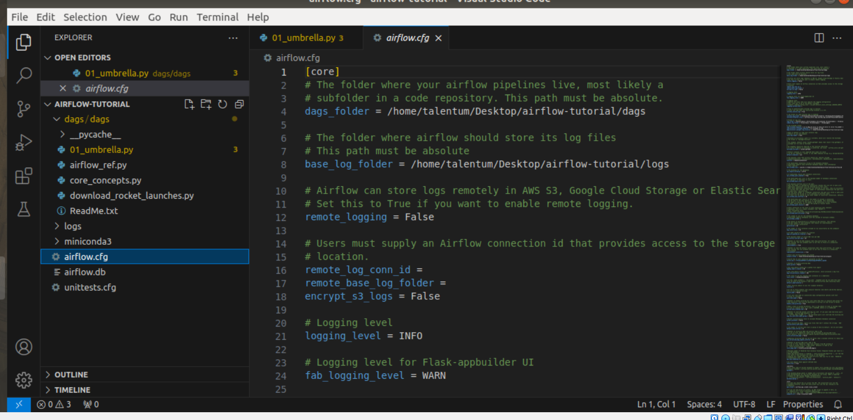

**Search for “examples”**

**You will get “load examples entry”**

**By default it is true**

**Make it false**

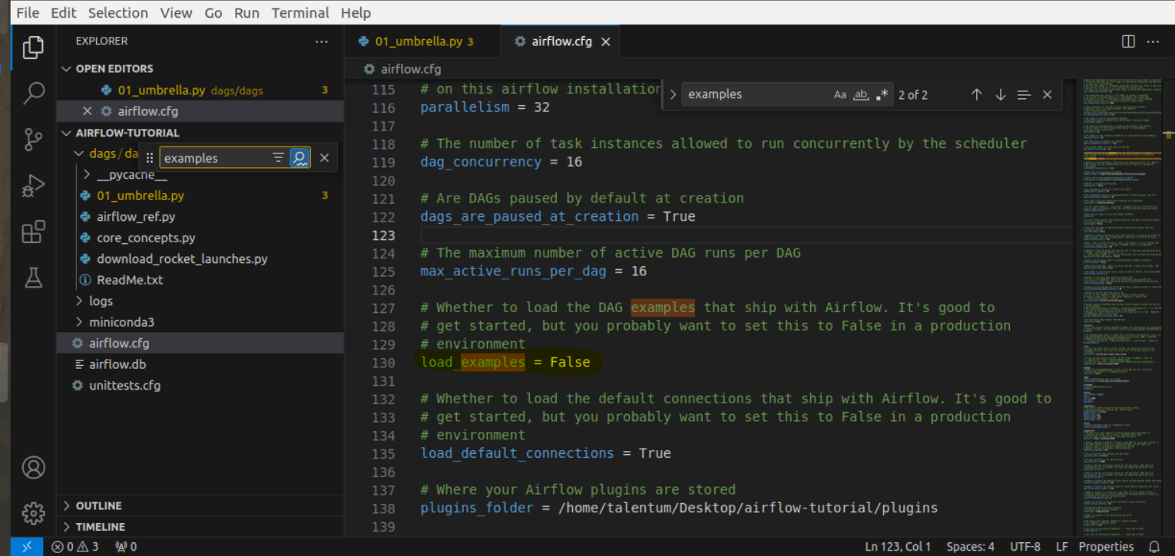

**Save it**

**Come back to browser and refresh**

**You will se no change ..hahah**

**You need to reset**

**Go to web server**

**Anf contrl c**



**Then do all steps again and refresh page**

**Non essential dags shoouls go away**

**Now “ON” D1**

**And TRIGGER IT**

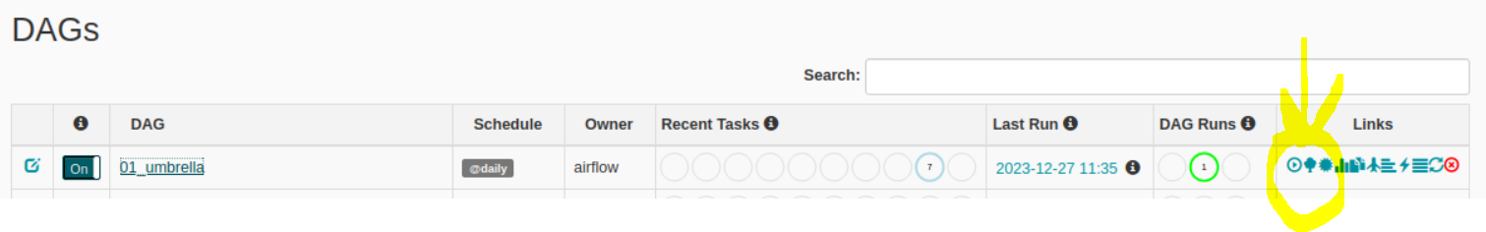

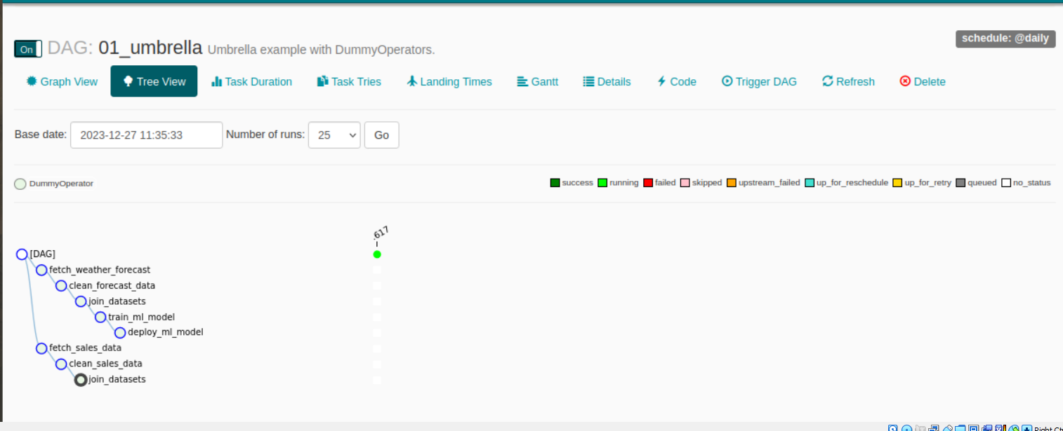

**Turn off D1**

**And on core_concepts**

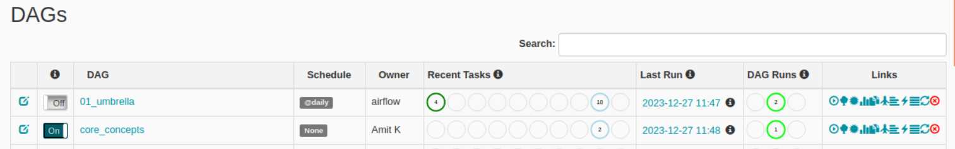

**Click on core_concepts**

* **Graph view**

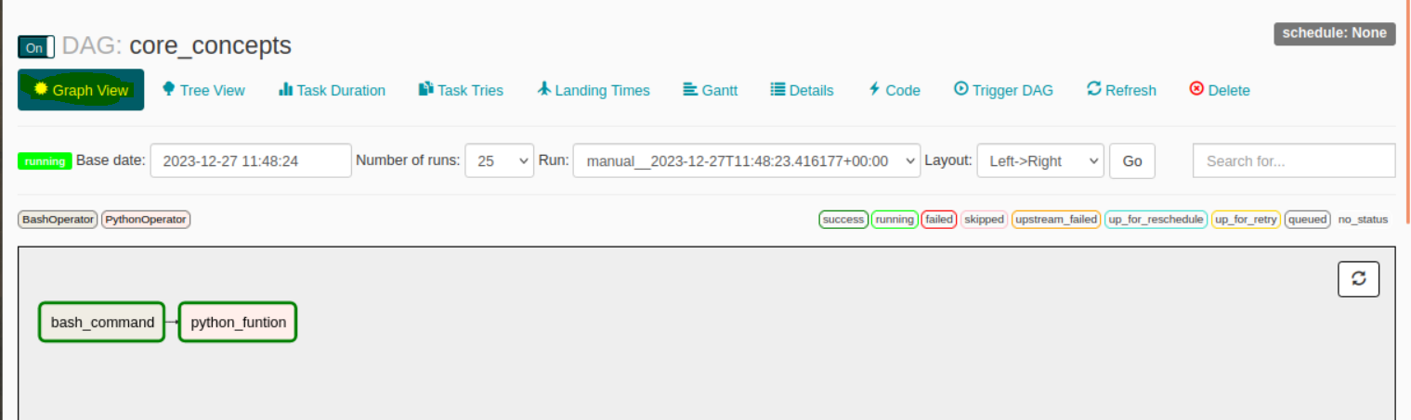

**Now click on python function**

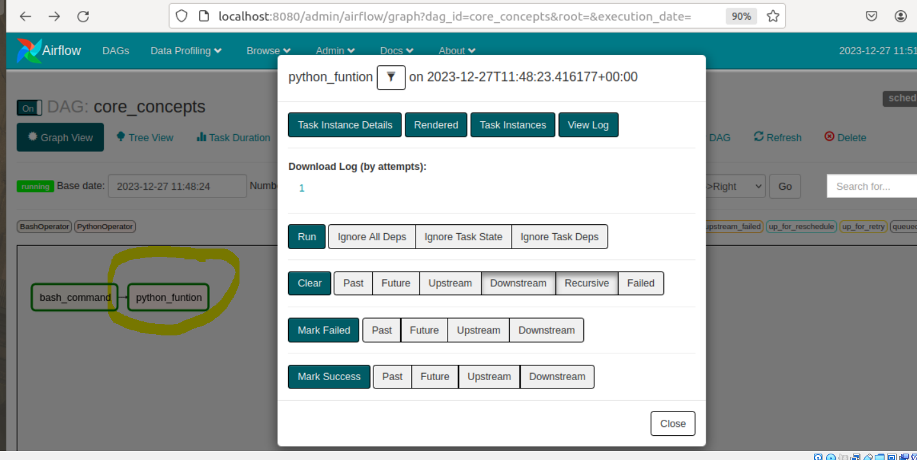

**Click on view log**

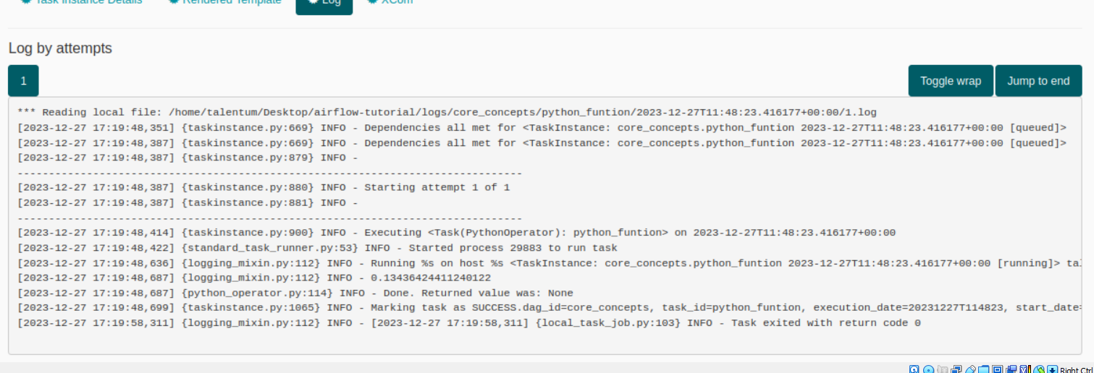

**You can view**

* **Task duration**
* **Task tries**
* **Details (these are required at time of audits) and it is very difficult to get in shellspark so airflow is best suited option**

**In admin->connections**

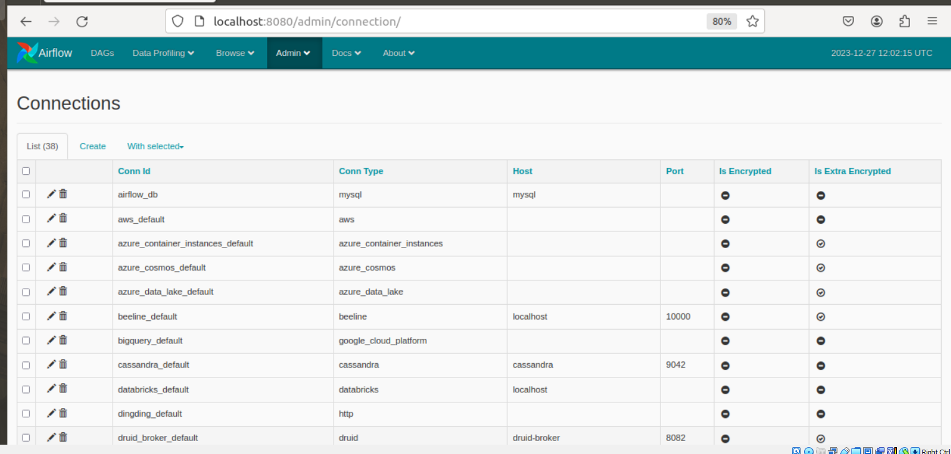



**I don’t want to run in yarn mode, I want to run in local mode**

**Edit**

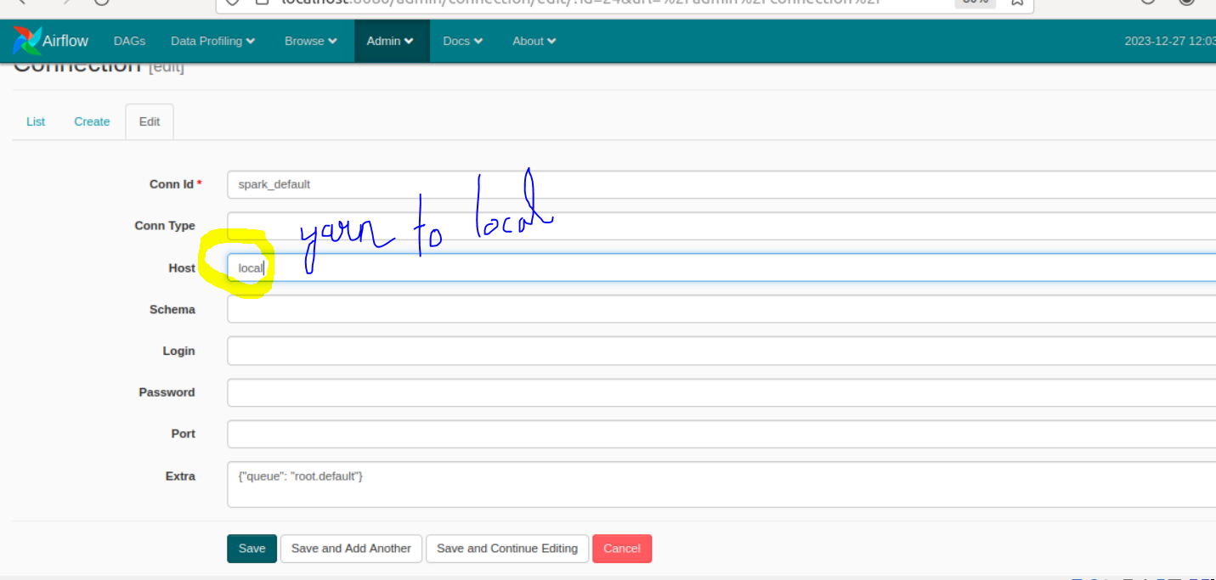

**Now switch off**

**And don examref**



**Click on examref->graph view->**

**Refresh**

**Green colour indicated running**

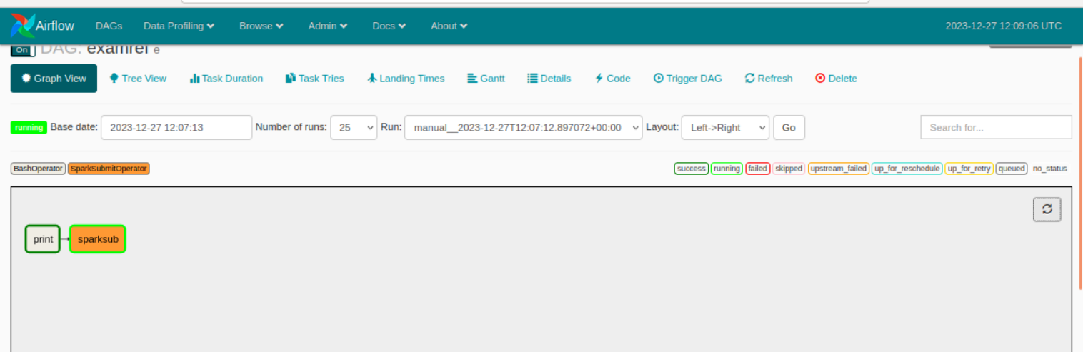

**It should be dark green for success**

**See “logs” if it failed**

**Refer airflow documentation for further**

**Sol-**

**FINALLY BC**

**Edit below path properly**

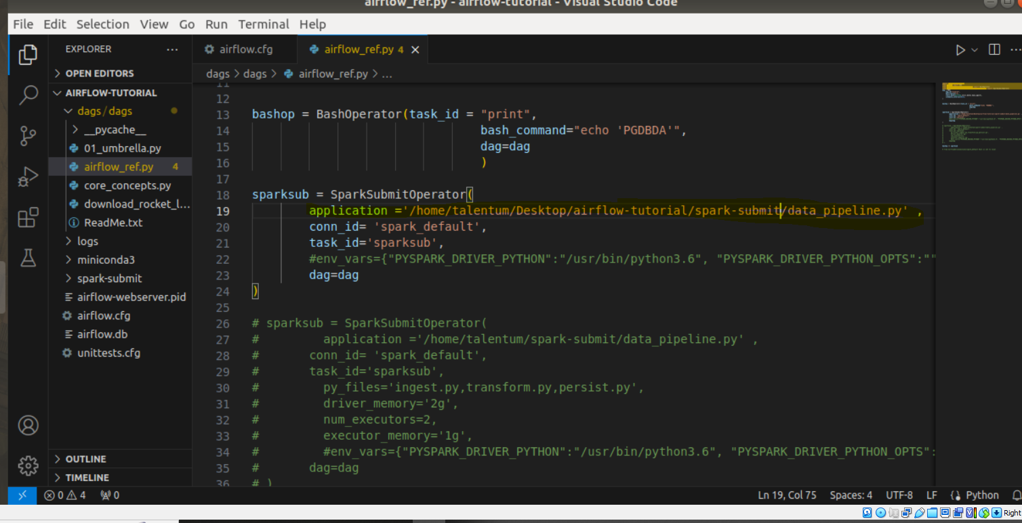

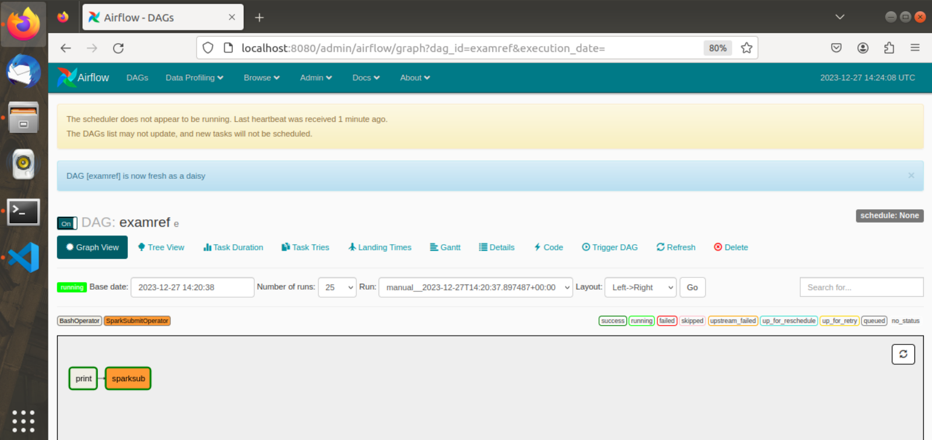

**-----------------------------------------------------------------------------------------------------------------------------------------**

**-------------------------------------------------SWAPNIL SIR---------------------------------------------------------------------**

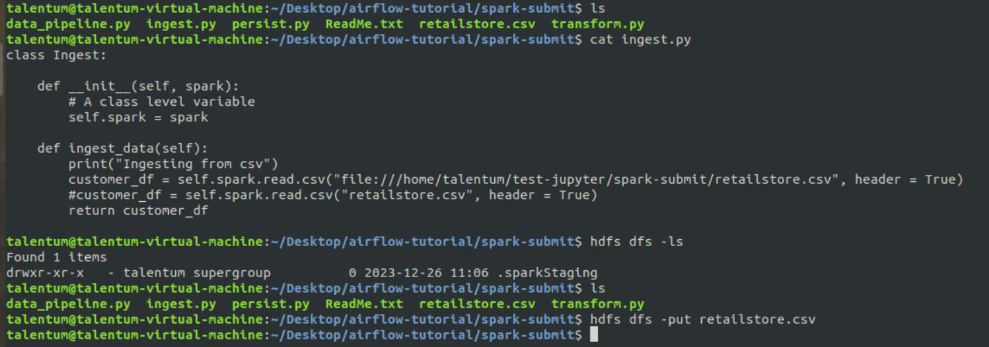

**Edit**

